Jyle Darling

M093437

WCAG Report

RAD Project Handover

Table of Contents

WCAG Requirements 1

Examples 2

# WCAG Requirements

WCAG stands for Web Content Accessibility Guidelines and has been put in place to provide a single shared standard for web content accessibility that meets the needs of individuals, organisations and governments internationally. The purpose of this standard is to make web content more accessible to people with disabilities and generally refers to a websites ‘content’ as the information in a web page or application, such as the text, images or sounds displayed in a web site or application, or the code or mark-up defined structure/presentation.

Below is simplified list of the upcoming WCAG 2.1 requirements needed in order for a webpage or application to be granted a AAA rating for compliance with the guidelines. A full comprehensive list of each principles criteria can be found at: <https://www.w3.org/WAI/WCAG21/quickref/>

**Principle 1 – Perceivable.**

Information and user interface components must be present to users in ways they can perceive.

* Provide text alternatives for non-text content.
* Provide captions and other alternatives for multimedia.
* Create content that can be presented in different ways, including assistive technologies, without losing meaning.
* Make it easier for users to see and hear content.

**Principle 2 – Operable.**

User interface components and navigation must be operable.

* Make all functionality available from a keyboard.
* Give users enough time to read and use content.
* Do not use content that causes seizures or physical reactions.
* Help users navigate and find content.
* Make it easier to use inputs other than keyboard.

**Principle 3 – Understandable.**

Information and the operation of the user interface must be understandable.

* Make text readable and understandable.
* Make content appear and operate in predictable ways.
* Help users avoid and correct mistakes.

**Principle 4 – Robust.**

Content must be robust enough that it can be interpreted by a wide variety of user agents, including assistive technologies.

* Maximise compatibility with current and future user tools.

# Examples

Below are some images of the way our website meets some of the WCAG standards.

Guideline 1.1 – Text alternatives:

Our website contains a couple of chart images generated by users searching movies, and users rating movies contained in the database. The chart images show the top ten results of each of these user interactions. A method was put in place so that the alt text would contains the data used to populate the chart.



Figure 1 webpage code



Figure 2 webpage data when inspected in google chrome

Guideline 1.4.1 Use of Colour

Our website has separated different features or functions with not only colour, but by text indicators, this allows people using the website who may be colour blind to still distinguish between different functions or elements in the website.

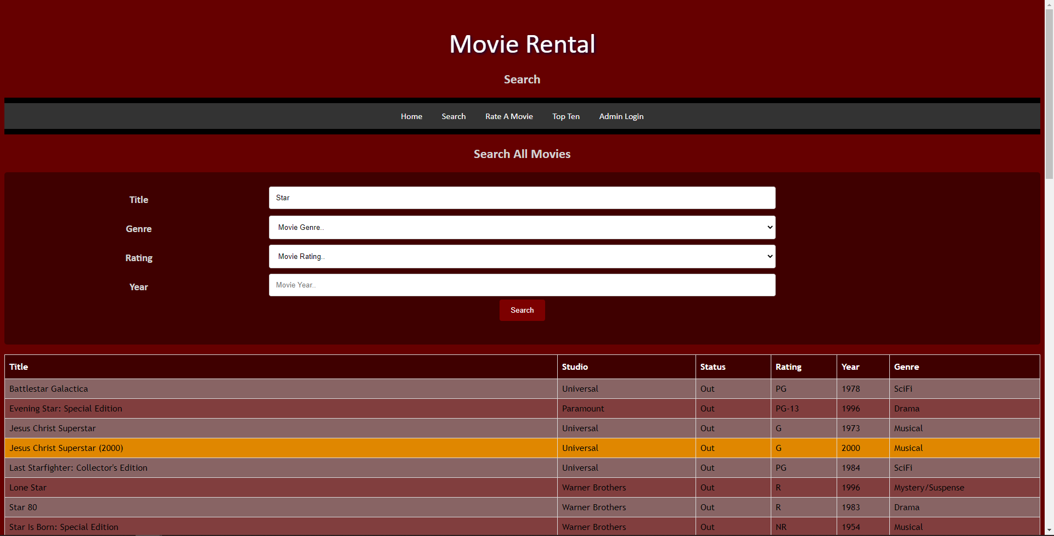

Figure 3 webpage providing different colours for separated elements